Content Monetization Modeler
Overview :

Domain : Social media Analysis
A Machine Learning project that predicts YouTube ad revenue in usd, for individual videos based on various performance and contextual features and implements the results in a simple Streamlit web application.
Project Deliverables:
- Understand the Dataset
- EDA (Exploratory Data Analysis)
- Feature Engineering
- Model Building
- Model Evaluation
- Streamlit App Development
- Interpretation & Insights
Input features:
- Video_id,likes,views,comments,watch_time minutes
- Date,Country,Device.
Target column:
- Ad_Revenue_usd.
Technology Used:
- Python 3.13
- Pandas
- Numpy
- Seaborn,Matplotlib,plotly
- Streamlit App
- Pickle and Joblib

Understand the Dataset:
- Read the dataset from csv format to data frame using pandas library
- Then, Understand the Dataset, like what are the input features and find out the target column
- Likes, subscribers…are input features.
- Ad_revenue is the target Column.
EDA (Exploratory Data Analysis):
- Getting an idea about datatypes and correcting those data types.
- Handled the Null values(5%), inputting the median values.
- Remove the duplicates values(2%).
- Encode the Categorical variables .(Country, Device, Category).
- Comprehensive statistical Analysis
- Correlation between input feature and target variable.
- Outliers’ detection and handling.
- Distribution Analysis of target variables.

Feature Engineering:
Creating the new features:
- Year,
- Month,
- Engagement rate = (Likes + Comments) / Views.

Model Building:
Here 5 different kinds of models are utilized.
Linear Regression, Ridge, Lasso, gradient boost regressor, Random forest
Regressor.

Model Evaluation:
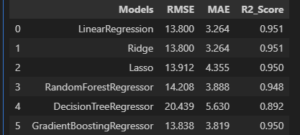
From which i have taken one model and saved it in the pickle file format.
Model Selection:
Model : Linear Regression
Lowest RMSE : 13.80
Lowest MAE : 3.264

Feature selection also done by the model
Feature importance:
- Watch time minutes
- Likes
- Comments
- Views , these are important features predicted by the model.
Realtime predictions:
Realtime time predictions based on user input done.
Based on input clearly display the Ad_revenue output.
Key Insights :
- All models achieved >95% R² score, indicating excellent predictive capability.
- Views, engagement metrics, and subscriber count are primary revenue drivers.
- Model consistency is linear relationship.

